Proposal to the

Smithsonian Astrophysical Observatory (SAO)

for work on the

Statistical Analysis, Prediction,

Modeling, and Visualization

of Solar Flare Data

in conjunction with the grant proposal

“Many Flares Make a Corona”

Submitted by

Bernhard Klingenberg

Dept. of Mathematics & Statistics

Williams College, MA

June 9, 2023

**1. Description and Outline of Work**

**1.1 Overview**

The primary work will be on the development, implementation and visualization of statistical procedures to model characteristics of solar flares based on satellite observations of hundreds of thousands of flares spanning two and a half solar cycles. A particular focus will be the development of a probabilistic model for the energy release for such flares. This is complicated by the fact that flares with low energy output are harder to observe than those with large energy output. The signature of low-energy flares is harder to detect amid the background noise, but also during times when the sun is very active and signatures of the many high energy flares swamp the signals from the lower energy flares.

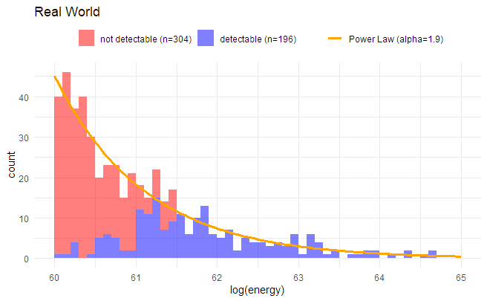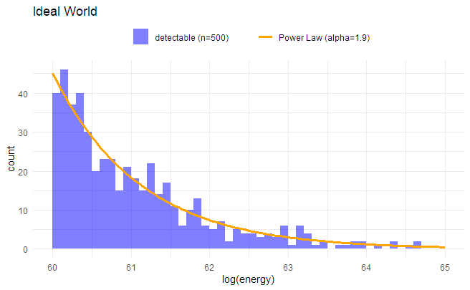Figure 1 illustrates the issue using simulated data. In an ideal world we could observe all flares occurring on the (visible part of the) sun, and, based on astrophysical considerations, might assume a Power-Law for the distribution of their energy releases, see the left panel in Figure 1. However, because of instrument and measurement limitations, many flares that have lower energy output can’t be identified from analyzing the stream of flux data, and are therefore missing from the data. Consequently, the energy distribution that we actually observe looks more like the blue distribution in the right panel of Figure 1.

Figure 1: Distribution of flare energies in an ideal world without measurement limitations (left panel) and with measurement limitations (right panel), where many low-energy flares cannot be observed.

Before exploring various statistical methods (maximum likelihood, maximum product of spacings, Bayesian) towards building a stochastic model for the flare energies based on the existing data on solar-flare energies, we hope to significantly supplement and enrich the existing data by identifying flares that have been missed using conventional algorithms of flare detections. We plan to use machine learning methods, in particular a convolutional neural network (CNN) or similar deep learning algorithms, to predict where flares may have occurred based on the available flux data. Similar methodology was used successfully by Feinstein et al. (2020)[1] to identify flares in transient exoplanet survey satellite short-cadence data, using an existing hand-labeled catalog of such flares to train the CNN.

**1.2 Augmenting the existing flare catalog**

The database that we are using for our analysis consists of 1-minute averages of X-Ray irradiance measurements from the GOES satellite[2]. This database includes information on when a potential flare occurred, determined from an algorithm based on the relative magnitude and rise of the flux measurements[3]. Our plan is to use this existing source of identified flares to train our CNN.

To test our approach, we created a dataset of all 1-minuted fluxes for the years 2021 and 2022 from the GOES catalog that is available online[4]. From it, we compiled a dataset of all the 4,203 flares that were identified in those two years. Similar to the approach taken by Feinstein et al. (2020), for each of these flares, we constructed a flare profile that consists of the fluxes 30 minutes prior to the flux for which the flare event was declared (called the peak flux), and the fluxes for the 15 minutes after the peak flux. Thereby, a flare profile consists of 46 flux values (with the peak flux in position 31), and covers a period of 46 minutes. Due to missing data, we could not create a profile for all 4,203 flares, but for 4,180 of them.

*Research Goal:* These values for a time span of 46 minutes were picked heuristically, and research needs to be done to assess if such a time span is sufficient for the CNN to learn about the background flux against which to assess the probable occurrence of a flare.

We did not use the raw flux measurements directly (they are measured in W/m2), but divided each of the 46 flux values in a profile by the flux value in position 31, which is where the peak flux was observed. Consequently, the value in position 31 of any profile is always equal to 1, while the other values are typically less than 1 (when there were no other flares in the 46-minute window). However, they can also be higher than one if the initial flux in a profile was higher (e.g., on a downward trend from a previous flare), or if another flare occurred before or right after the one considered. Figure 2 (top row) shows four selected flare profiles that are included in our dataset. These profiles will be used as the positive cases (labeled ‘flare’) in the training dataset.

To create a negative case (or control) profile, we randomly selected a minute between 2021 or 2022, but excluding those minutes where a flare was observed (i.e., the positive cases), and the 3-minute interval immediately before or after the identified flare. Then, we created the flare profile with the 30 flux values before, at and after the selected minute. We used the same standardization technique (dividing by the flux in position 31) as for the flare profiles. In total, we created 30 such control profiles for each of the 4,180 flare profiles. Figure 2 (bottom row) shows four selected control profiles. Overall, we thus have 4,180 + 125,400 = 129,580 profiles in our dataset.

We used 80% of this labeled (‘flare’, ‘no flare’) profile dataset to train the CNN, holding out the remaining 20% for evaluation. For the architecture of the CNN, for this proposal, we used the architecture and hyperparameters of the *stella* CNN developed in Feinstein et al. (2020), with minimal adjustments.

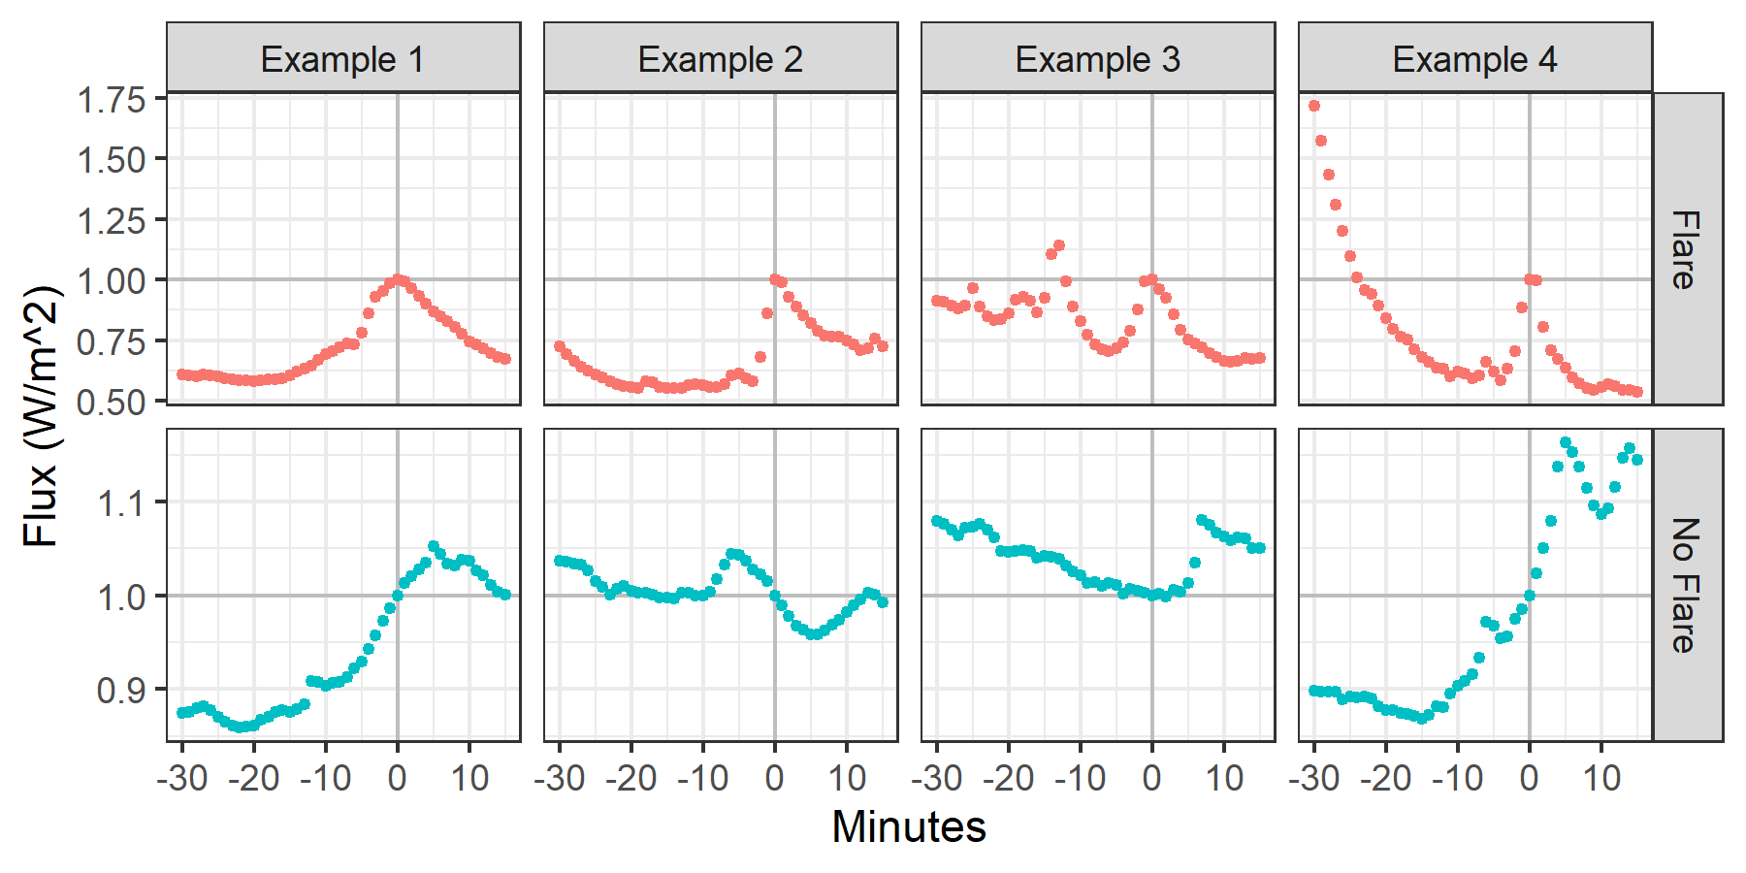

Figure 2: Examples from the training dataset of various profiles of flares (top row) and non-flares, the controls (bottom row). Profiles consist of 46 consecutive flux values, each divided by the flux value in position 31. We labeled position 31 as minute 0, the first flux observation in a profile as minute -30 (as it occurs 30 minutes before), and the last observation as minute 15.

*Research Goal:* Considerable effort will have to be devoted to develop, train and optimize a CNN that is sensitive to the characteristics of the GOES X-ray data. Feinstein et al. (2020) specifically mention their CNN should only be used for light curves as derived from the transiting exoplanet survey satellite (TESS) data. Also, although Feinstein et al. (2020) published their CNN algorithm in a github repository[5], they use an older Python library that now is obsolete, and we could not reproduce their analysis. We plan to published the Python code for the flare predictions via a CNN that we develop under this research in a github repository.

Using the training data as described above (which contained 3,356 flare profiles) to train the CNN, we obtained an accuracy of 96.49% (= 24,263/25,145), a precision of only 48.26% (= 804/1,666) and a recall of 97.57% (= 804/824) on the test dataset, which contained 824 flares. The high recall is desirable, as we should be able to reproduce the flares that the arguably more conservative conventional method identified. The low precision is not of concern at this stage, as we know the current flare catalog missed many of the smaller flares, which we hope our CNN will pick up. Investigating significant more time in obtaining and optimizing training datasets and fine-tuning the CNN, will pay off for all these metrics.

To illustrate the potential of our approach for expanding the existing flare catalog, Figure 3 shows flux measurements taken between February 2 and February 11, 2022. During this period, 199 time points were identified as the peak flux of a flare, using the conventional algorithm. These time points (unit: 1 minute) are published on the GOES website and are shown as red dots in Figure 3.

To obtain a prediction of the likelihood of a flare going off at any particular minute, we created a flux profile as described above: We put the flux at the desired minute in position 31 of the profile, with positions 1 – 30 consisting of the fluxes of the previous 30 minutes, and positions 32 – 46 consisting of the fluxes of the following 15 minutes. This profile is then fed into our CNN and we obtain a prediction score as an output. This prediction score can be used to predict whether the input profile at that minute has the characteristics of a flare. We did this for every single minute in the time interval. The green dots in Figure 3 indicate all instances where the CNN identified a flare, using certain settings of hyperparameters (most importantly, the threshold over which a profile is declared a flare).

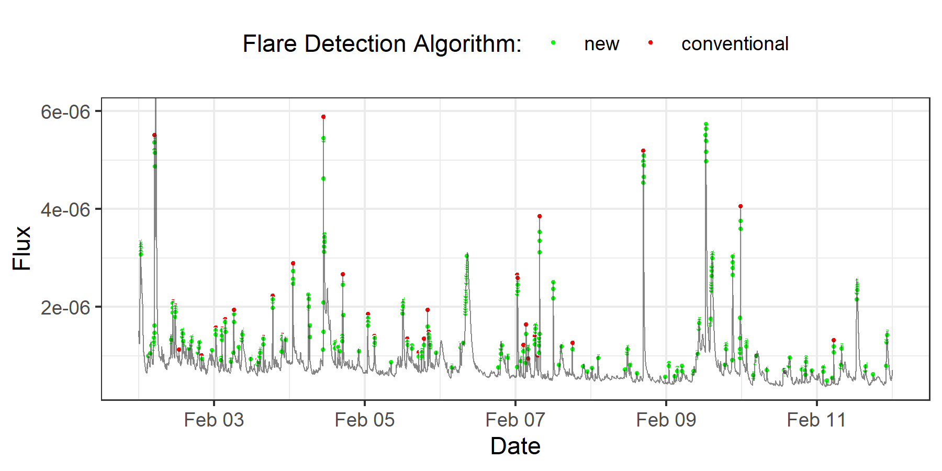

Figure 3: Fluxes observed between February 2 and February 11, 2022 (gray line). Time points (unit = 1 minute) where the conventional algorithm indicated a flare are marked by red dots. In all but 4 of the 199 cases a flare was identified by the conventional algorithm, they were also identified by the CNN. In addition, green dots indicate time points where the CNN identified a flare, but the conventional method did not.

Using the CNN, we seem to be able to identify many more flares, in particular those of smaller amplitudes. And judging by the flow of the flux, the overwhelming majority of those newly identified time points indeed seem to correspond to flares.

**1.3 Modeling the flare energy distribution**

*… work in progress ….*

My goal is to propose a reasonable model for flare energy release and rigorously check if this model is supported by the available data. This entails fitting the model to the data, which traditionally has been done using maximum likelihood methods. These methods, however, have known limitations in this setting: Because the energy output of flares, being sudden bursts generated by the magnetic field, varies over several order of magnitudes, it may be reasonable to model the energy release as a power law (see Figure 1). Estimation of the power law index (alpha) is complicated by the fact that the onset of the power law (the energy level below which no flares would occur) is unknown and maximum likelihood estimators for it may not perform satisfactorily. A significant amount of my work will investigate a Bayesian approach to model fitting. Preliminary simulation results carried out by me look very promising in more accurately estimating these key characteristics of flare energy distributions.

Another strand of work will relate to investigate the almost canonical assumption that the number of flares with energies in a given (small) interval follows a Poisson distribution. Our preliminary analysis show that this assumption, for various reasons mentioned elsewhere, may not be valid. I plan to investigate alternative models that take over-dispersion relative to the Poisson model into account. The Bayesian approach is especially suited for such an approach, as an extension of the Poisson distribution is the negative binomial distribution, resulting from the mixture of a Poisson distribution with a gamma distribution. My hope is that such a modeling approach more accurately predicts the average number of flares occurring, but also accurately describes the variability in the number of flares.

A parametric modeling approach as outlined so far is not the only approach towards analyzing solar flare characteristics. Another research team has proposed a novel semi-parametric approach, and part of my work will be a comparison between these two different approaches. It will be interesting to see for the research community if the more traditional parametric approach results in similar conclusions and estimates as the semi-parametric approach.

Finally, for both model development and dissemination of our results to the larger research community, it is important to create appropriate visuals that help in the description of the model and our predictions, but also visualize uncertainties. Part of my work will focus on creating online, interactive web apps based on the work described here.

**2. Expertise**

I’m a Professor of Statistics at Williams College specializing in statistical modeling, consulting and data visualization. I will provide my statistical expertise, including expertise in the statistical computer language R and the R shiny package for creating interactive web apps to the overall goal of understanding and modeling key characteristic of solar flares.

**3. Time**

I plan to work for 2 months for each of three years to carry out the work given in the description above.

|  |  |
| --- | --- |
| **Year** | **Description of Work** |
| 1 | Model development & formulation. Simulation to explore characteristics and features such has overdispersion. |
| 2 | Maximum Likelihood and Bayesian model fitting and simulations in R. Model checking. |
| 3 | Writing up results and developing visuals for internal and external dissemination of results, including the creation of web aps |

**4. Travel**

Although most research meetings with the larger team can be carried out over Zoom, the collaborative nature of this research with experts in astrophysics and statistics necessitates a few in-person meetings to effectively discuss modeling and implementation issues, and to obtain and incorporate feedback that is too difficult to relay over Zoom. Since the principal investigator is located in Cambridge, MA, I’m asking for travel between Williamstown, MA and Cambridge, MA.

For the first and second year, I’m budgeting for two trips to Cambridge, each for two days. For the third year, I’m budgeting for one trip to Cambridge.

For the second year, I’m budgeting a three-day, two-night trip to the University of Michigan to meet with grant collaborators to work on the parametric modeling approach to solar flare analysis.

This work is interesting to the broader astrophysical and statistical community and I’m planning to present our approach and results at the joint statistical meeting, held in Portland, OR, in August 2024, in year 3.

**5. Current & Pending Support**

I have no current or pending support from any other grant or agency.

1. Feinstein, Montet, Ansdell, Nord et al. (2022). Flare Statistics for Young Stars from a Convolutional Neural Network Analysis of TESS Data. *The Astronomical Journal*, 160:219
2. https://data.ngdc.noaa.gov/platforms/solar-space-observing-satellites/goes/goes16/l2/docs/GOES-R_XRS_L2_Data_Readme.pdf
3. See Appendix A in https://data.ngdc.noaa.gov/platforms/solar-space-observing-satellites/goes/goes16/l2/docs/GOES-R_XRS_L2_Data_Users_Guide.pdf
4. https://www.ngdc.noaa.gov/stp/satellite/goes-r.html
5. https://github.com/afeinstein20/stella